SPRINT – 2

**Data Visualization Chart (Yearly usage of Area in Crop Production)**

|  |  |
| --- | --- |
| Date | 19 November 2022 |
| Team ID | PNT2022TMID20305 |
| Project Name | Estimate The Crop Yield Using Data Analytics |

Using the Crop production in Indian dataset, create various graphs and charts to highlight the insights and visualizations.

* Showcase the Yearly usage of Area in Crop Production

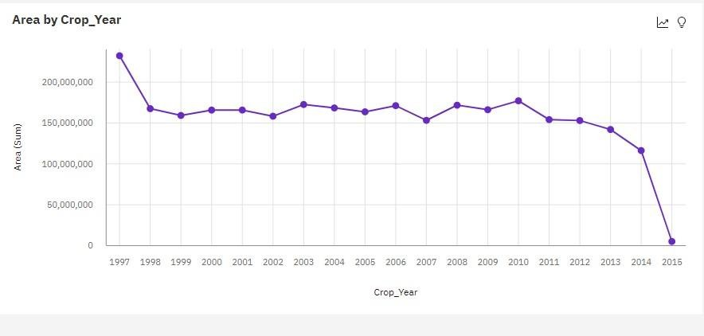

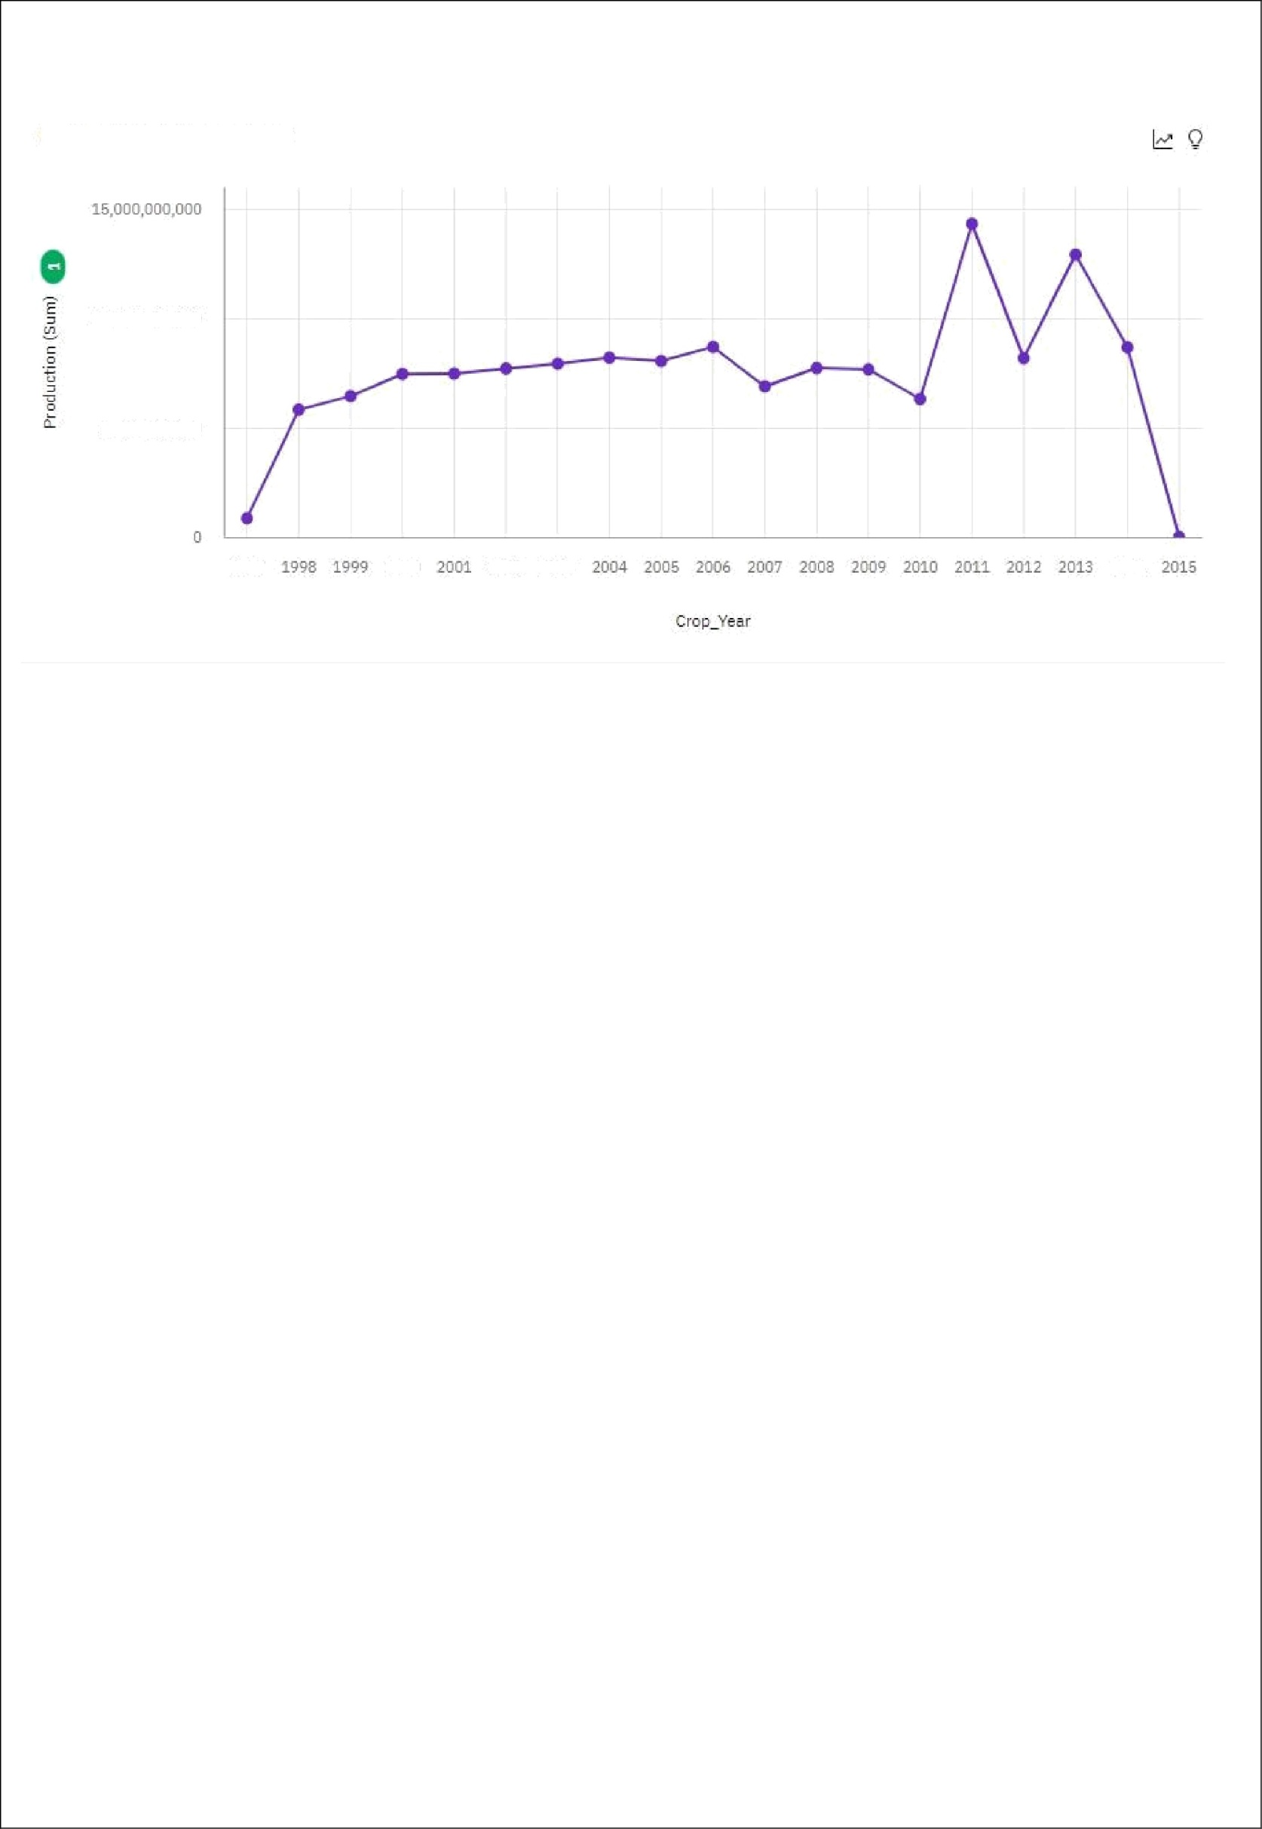Production by Crop_Year

1D,00D,000,OOO

5,00D,000,OOO

i997 ZOQO 2D02 20D3 2014